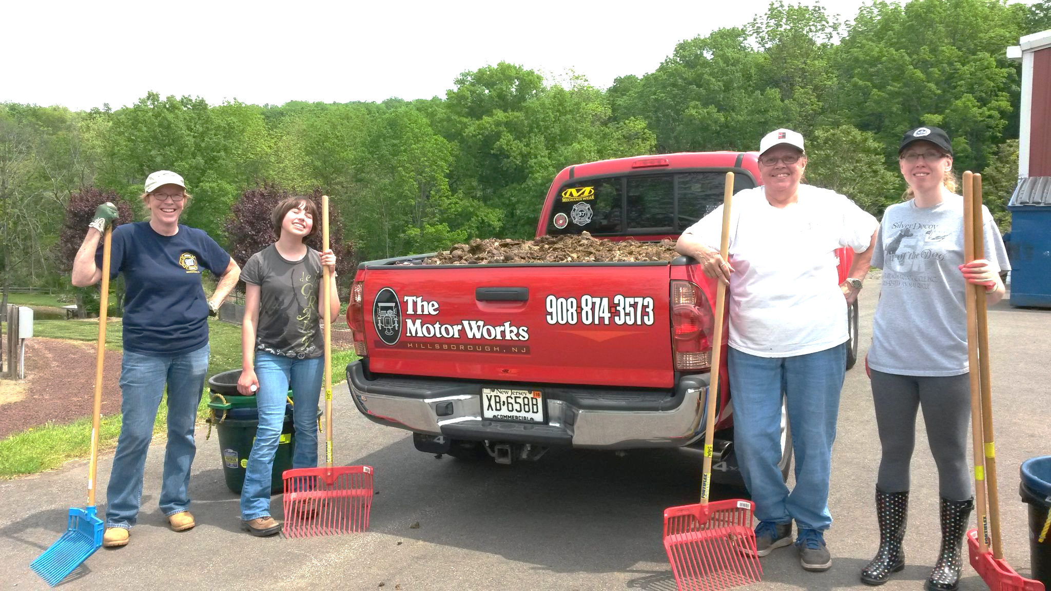
Spring Reins of Life needs your Help on Weekends for Farm Clean-up!

- No special skills needed
- Physical Work (muscle)
- Groundskeeping/ Landscaping
- Pasture Cleanup
- Cleaning (client rooms)
- Maintain equipment
- Help Grass Growth
- Outdoor/Indoor Chores
- Youth / Church Groups
- Family friendly
- Corporate Volunteer Day
- Great for Service Hours
- Scout Badges-Projects

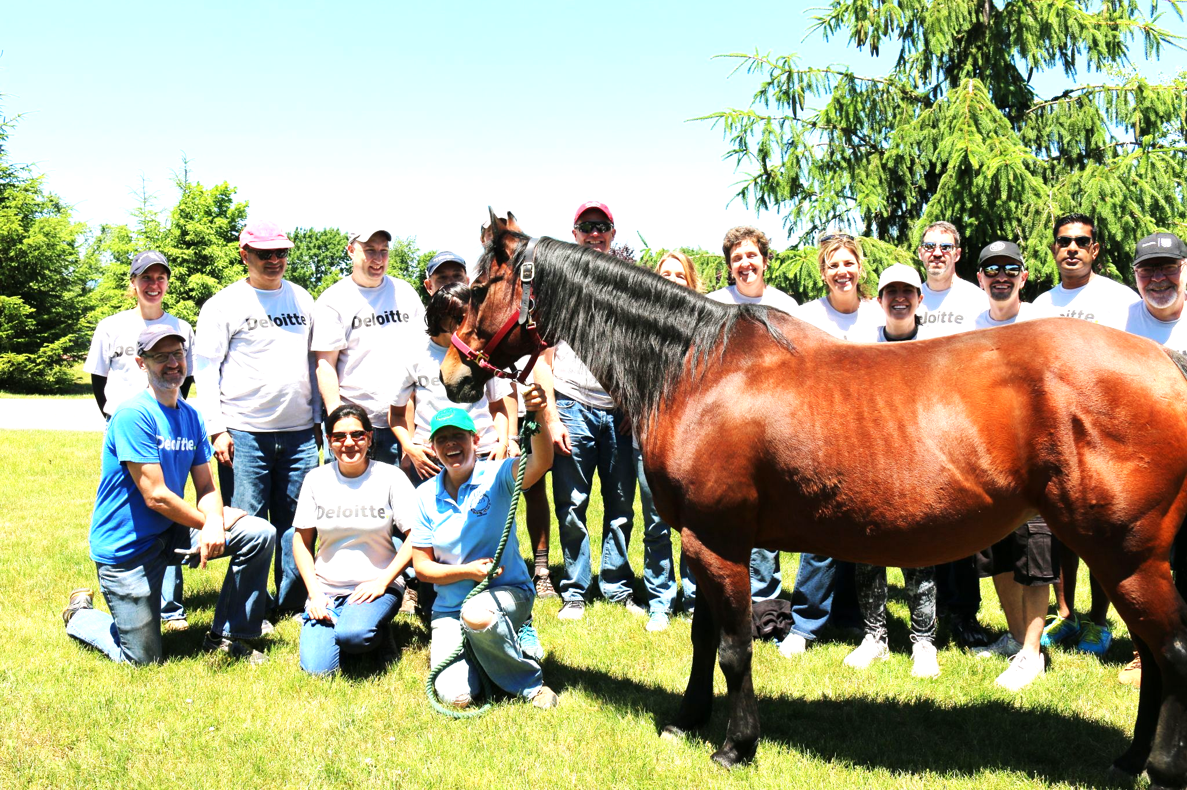

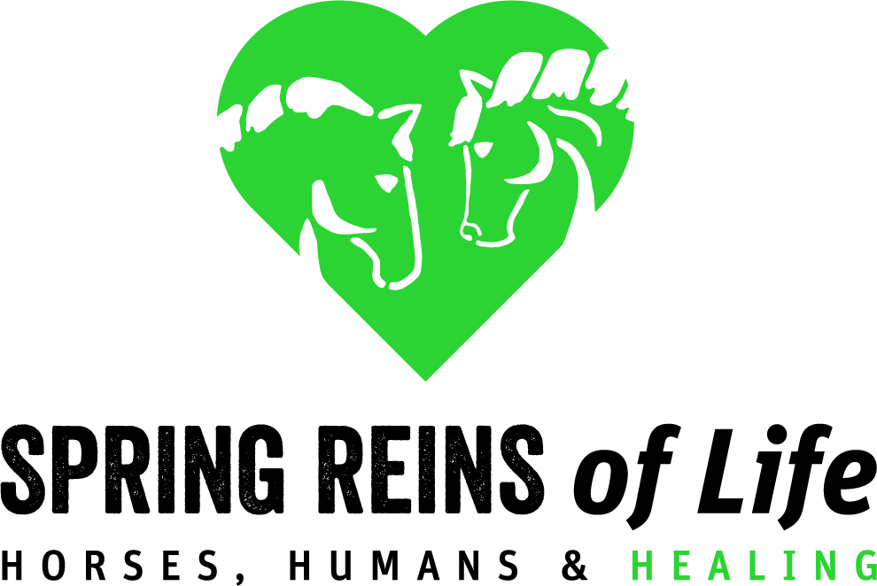
401 Main Street
Three Bridges, NJ 08887
www.SpringReinsofLife.org
Saturdays 11a-2p and Sundays 12-2p
Email Robin: volunteer@springreinsoflife.org

